**Web Assignment 3**

In this assignment you are required to mimic the basic functionalities of **notes** app readily found in smartphones. Image has been attached below to avoid any ambiguities.

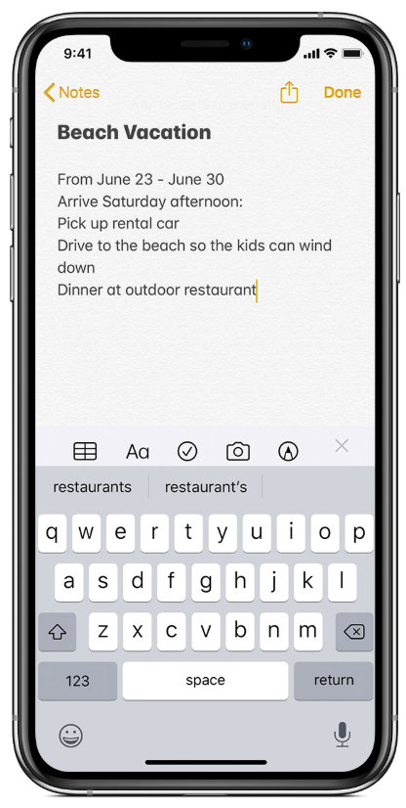

**Requirements:**

1. **Login Page** to let user log in. Apply necessary checks on the input fields. (You may register new users directly via phpmyadmin)
2. **Landing page** of your site that let’s user save new notes and view previously saved notes. When the page gets loaded, it should show only 2 buttons namely **‘New Note’** and **‘Show Notes’**.
3. When **‘New Note’** is clicked, two text input fields should be displayed. One for Note title and other for note content. Upon submission of the form, that entry should be inserted into the database. Content of notes shouldn’t exceed 100 characters.
4. When **‘Show Notes’** is clicked, a **table** should be displayed. Columns should include **Title, Content, Time Saved, and Delete button** to deletethat corresponding note**. User can only view notes saved by him previously and not that of others.**
5. **Input fields** and **Saved notes** table should be loaded upon logging in and only displayed using **DOM** manipulation and not by reloading the page.
6. **Upload .sql file, .txt file containing query used to create the table to store the notes, and .php files.**
7. **NO CSS REQUIRED.**

**Hint: This assignment requires use of Php Sessions**